APARTMENT VISITOR LOG
@CREATIVITY THINK (9483175986/7019689991)

ABSTRACT:
Apartment Visitor Log is a web application designed to enhance security and visitor management in residential complexes and gated communities. Users can log visitor details, request approvals, and receive notification alerts. Administrators review logs, manage resident details, and monitor dashboard analytics for visitor activity. Built with Django and Django Rest Framework for backend processing, and React, axios, and chart.js for frontend interactivity and reporting, this system centralizes visitor data, automates approval workflows, and provides comprehensive analytics for both users and administrators, ensuring enhanced security and efficient visitor management..

INTRODUCTION OF THE PROJECT:
Managing visitors in apartments and gated communities manually can be prone to errors and delays. Apartment Visitor Log offers a centralized solution where visitors can be logged, approvals can be managed, and notifications sent automatically. Administrators can monitor visitor activity, manage residents, and view analytical reports on the dashboard. The backend handles authentication, logging, and approval workflows, while the frontend provides an interactive interface with charts and notifications. This platform ensures timely approvals, streamlined visitor tracking, and enhanced security for residents and administrators..

PROJECT OBJECTIVES:

• Enable residents to log visitor details efficiently
• Automate approval alerts for visitors
• Allow administrators to review and manage visitor logs
• Provide dashboard analytics for visitor trends
• Offer search and filter functionality for visitor records
• Enhance apartment security and monitoring processes
• Generate reports and notifications for residents and admins
• Ensure secure storage of visitor and resident data

PROBLEM OF THE STATEMENT:
Manual visitor logging in apartment complexes is inefficient, leading to delays in approvals, missing records, and reduced security. Residents and administrators lack a centralized system for tracking visitor activity and managing approvals. Apartment Visitor Log addresses these challenges by automating visitor logging, approval alerts, notifications, and dashboard analytics. It provides a secure platform for managing visitor data, streamlines approval workflows, and enables administrators to monitor trends and generate reports for enhanced security and operational efficiency..

MOTIVATION OF THE PROJECT:
• Improve apartment and gated community security
• Centralize visitor logging and resident management
• Automate approval and notification workflows
• Provide analytics for visitor activity and trends
• Streamline reporting for administrators and security teams

BLOCK DAIGRAM OF PROJECT:

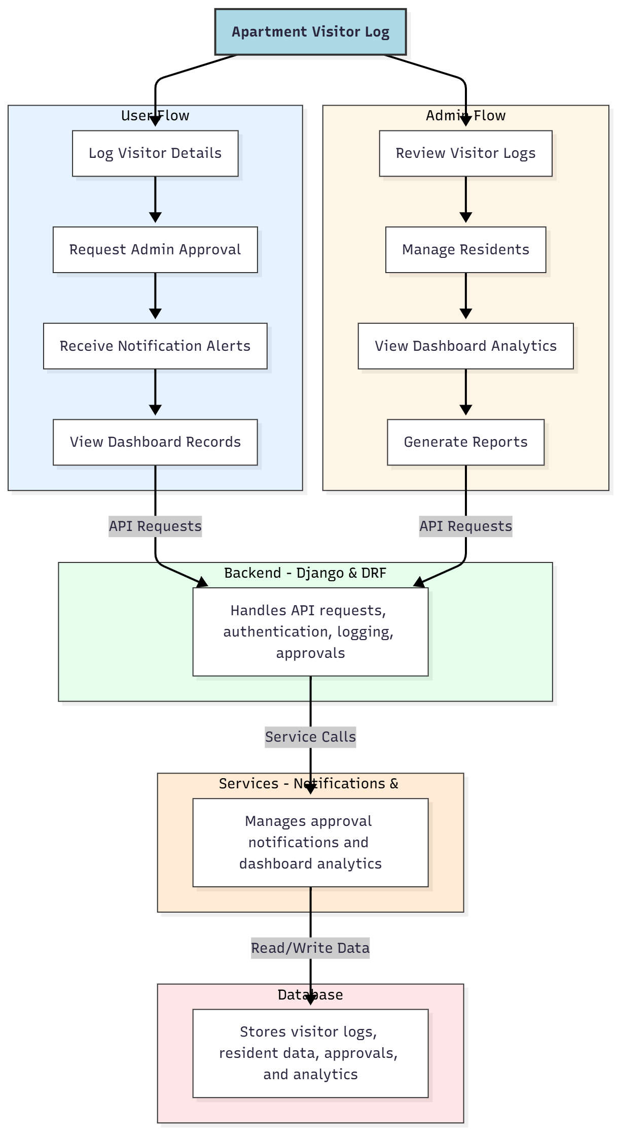

WORKING OF THE PROJECT:
Residents log visitor details including name, contact information, and purpose of visit. Requests are sent to administrators for approval, and residents receive notification alerts when actions are taken. Administrators review logs, manage resident details, monitor dashboard analytics, and generate reports. The backend handles authentication, logging, and approval workflows, while services manage notifications and dashboard analytics. The database stores visitor logs, resident information, approvals, and analytics. The system ensures efficient visitor tracking, timely approvals, and enhanced security in apartment complexes..

SOFTWARE REQUIREMENT:
- Backend:
  - Python 3.x
  - Django
  - Django REST Framework
  - SQLite/PostgreSQL
- Frontend:
  - Node.js and npm
  - React.js
  - Axios
- Development Tools:
  - Visual Studio Code
  - Postman (for testing APIs)
  - Git/GitHub (for version control)
- Server/Deployment (Optional):
  - Gunicorn, Nginx, or Heroku/AWS for hosting

ADVANTAGES OF THE PROJECT:

• Centralizes visitor logging and management
• Automates approval workflows and notifications
• Provides searchable and filterable visitor records
• Displays dashboard analytics for administrators
• Enables report generation for visitor activity
• Enhances security for apartments and gated communities
• Reduces manual errors in visitor tracking
• Provides real-time notifications for residents and admins

APPLICATIONS OF THE PROJECT:
• Apartment complexes and gated communities
• Residential security management
• Visitor logging for offices or corporate buildings
• Security guard workflow management
• Real-time notifications for approvals
• Dashboard analytics for management
• Reporting and historical visitor tracking
• Integration with access control and security systems

REFERENCES:

- Django REST Framework Documentation — Django Software Foundation. Django Documentation. Available: https://docs.djangoproject.com/
- Django REST Framework. DRF Documentation. Available: https://www.django-rest-framework.org/
- React. React Official Documentation. Available: https://reactjs.org/docs/getting-started.html
- Redux. Redux Documentation. Available: https://redux.js.org/introduction/getting-started
- PostgreSQL Global Development Group. PostgreSQL Documentation. Available: https://www.postgresql.org/docs/
- MySQL. MySQL Reference Manual. Available: https://dev.mysql.com/doc/
- Git. Git Documentation. Available: https://git-scm.com/doc
- Node.js. Node.js Documentation. Available: https://nodejs.org/en/docs/
- Axios. Axios Documentation. Available: https://axios-http.com/docs/intro
- Socket.io Documentation – https://socket.io/docs/

